STREAMFLIX CONTENT ANALYTICS
DATA ANALYTICS INTERNSHIP
FINAL PROJECT REPORT
An End-to-End Analytics Project covering Data Cleaning, Exploratory Data Analysis, KPI Development, SQL Analysis, and Power BI Dashboard Design

Prepared By | Sujal Pal
Position | Data Analytics Intern
Organization | Intermo
Internship Status | Ongoing
Report Date | July 2026

Table of Contents
Executive Summary 3
Chapter 1 — About Intermo 4
Chapter 2 — Project Overview 6
Chapter 3 — Dataset Description & Data Dictionary 9
Chapter 4 — Tools & Technologies Used 11
Chapter 5 — Project Methodology 12
Chapter 6 — Data Cleaning & Preprocessing 13
Chapter 7 — Exploratory Data Analysis (EDA) 14
Chapter 8 — Key Performance Indicator (KPI) Analysis 20
Chapter 9 — SQL Database Design and Analysis 22
Chapter 10 — Power BI Dashboard Development 23
Chapter 11 — Business Insights & Recommendations 26
Appendix A — Star Schema Design 27
Appendix B — DAX Measures 28
Appendix C — Python Workflow 29
Appendix D — Challenges Encountered 30
Appendix E — Skills Gained 31
Appendix F — References 32

Executive Summary
This report presents the work completed during my ongoing Data Analytics Internship at Intermo. As part of the internship, I designed and delivered an end-to-end analytics solution for a fictional streaming platform, StreamFlix, to demonstrate practical data analytics skills and to support business decision-making.
The project involved collecting and preparing six interconnected datasets covering subscribers, titles, watch history, ratings, reviews, and watchlists — together comprising over 980,000 records. After cleaning and transforming the data in Python, exploratory data analysis (EDA) was carried out to uncover usage patterns, content performance, and customer engagement trends.
Key business metrics were calculated across subscriber, engagement, content, revenue, and customer-experience categories, including a subscriber base of 15,000 (11,199 active, a 74.66% active rate), 3.33 million total watch hours, a 65.31% average completion rate, $175,868.51 in monthly recurring revenue (MRR), and a $15.70 average revenue per user (ARPU). SQL was used to answer twelve business questions, and a star-schema data model was designed to support fast, scalable reporting.
Finally, an interactive five-page Power BI dashboard was developed, covering Engagement Overview, Content Performance, Subscriber Insights, Customer Experience, and Catalogue & Investment. Together, the analysis shows a platform with strong engagement and a loyal core subscriber base, alongside clear opportunities to reduce churn, expand Original content investment, and improve the recommendation experience. The project demonstrates the practical, end-to-end application of Python, SQL, and Power BI to a realistic business analytics problem.

Key Results at a Glance
Metric | Value
Total Subscribers | 15,000
Active Subscribers | 11,199 (74.66%)
Total Watch Hours | 3,333,467.73
Average Completion Rate | 65.31%
Monthly Recurring Revenue (MRR) | $175,868.51
Average Revenue Per User (ARPU) | $15.70
Total Titles | 9,000 (5,336 Movies / 3,664 TV Shows)
Original Content Share of Watch Hours | 27.17%
Average Content Rating | 3.55 / 5
Watchlist Conversion Rate | 46.23%

Chapter 1 — About Intermo

1.1 Company Overview
Internmo helps students and professionals gain practical skills through industry-focused learning, real-world projects, internship opportunities, and placement support. Learn, build, experience, and grow your career with confidence.
As a Data Analytics Intern, I was assigned an end-to-end analytics project simulating a real streaming platform. The internship provided exposure to the complete analytics lifecycle, including data collection, preprocessing, exploratory data analysis, KPI development, SQL-based analysis, data modeling, and interactive dashboard creation using Power BI.

1.2 About the Internship
Internship Position: Data Analytics Intern
Organization: Intermo
Internship Status: Ongoing
Department: Data Analytics
During the internship I worked on a business-oriented project titled “StreamFlix Content Analytics,” which involved analyzing streaming platform data to derive actionable insights that support business decision-making, covering the complete workflow from raw data processing to executive dashboard development.

1.3 Roles and Responsibilities
- Understanding business requirements and project objectives.
- Collecting and organizing datasets from multiple sources.
- Cleaning and preprocessing raw data using Python.
- Handling missing values, duplicate records, and inconsistent data.
- Performing Exploratory Data Analysis (EDA) to identify trends and patterns.
- Developing key business performance indicators (KPIs).
- Writing SQL queries to answer business questions.
- Designing a Star Schema for efficient reporting.
- Building interactive Power BI dashboards.
- Generating business insights and recommendations.
- Preparing technical documentation and this final report.

1.4 Internship Objectives
- Apply data analytics concepts to solve business problems.
- Gain practical experience with Python, SQL, and Power BI.
- Improve data cleaning and preprocessing skills.
- Learn to calculate and analyze business KPIs.
- Build interactive dashboards for executive reporting.
- Develop data storytelling and visualization skills.
- Understand the complete end-to-end analytics workflow.

1.5 Technologies Used
Category | Technology
Programming Language | Python
Data Manipulation | Pandas, NumPy
Data Visualization | Matplotlib
Database Querying | SQL
Dashboard Development | Power BI
Development Environment | Visual Studio Code, Jupyter Notebook
Version Control | Git & GitHub

1.6 Internship Workflow
The project followed a structured analytics workflow: Business Requirement → Data Collection → Data Cleaning & Preprocessing → Exploratory Data Analysis → KPI Development → SQL Business Analysis → Star Schema Design → Power BI Dashboard Development → Business Insights & Recommendations → Final Project Documentation.

1.7 Key Learning Outcomes
- Work with large, structured datasets (six tables, ~980,000 combined records).
- Perform data preprocessing efficiently.
- Analyze customer behavior using statistical techniques.
- Create meaningful, business-aligned KPIs.
- Write optimized SQL queries against a star schema.
- Design scalable data models.
- Develop interactive dashboards in Power BI.
- Present analytical findings in a clear, business-focused manner.
Chapter Summary: This chapter introduced Intermo, the internship role, and the objectives of the internship, along with the technologies used and the overall workflow followed during the StreamFlix Content Analytics project. The next chapter introduces the project itself.

Chapter 2 — Project Overview

2.1 Introduction
The StreamFlix Content Analytics Project is an end-to-end data analytics project developed during my internship at Intermo. It focuses on analyzing streaming platform data to understand subscriber behavior, evaluate content performance, measure customer engagement, and provide actionable business insights.
Streaming platforms generate millions of user interactions every day — content viewing, ratings, reviews, subscriptions, and watchlist activity. Analyzing this data enables organizations to understand customer preferences, improve content strategy, increase subscriber retention, and make informed business decisions.

2.2 Business Problem
Streaming platforms face several recurring challenges, including:
- Understanding subscriber viewing behavior.
- Identifying the most popular content.
- Measuring customer engagement.
- Monitoring subscriber churn.
- Optimizing investment in licensed content.
- Improving customer satisfaction.
- Increasing subscriber retention.
- Supporting strategic decisions with data rather than intuition.

2.3 Project Objectives
- Analyze subscriber behavior and engagement.
- Evaluate content performance across genres.
- Measure platform performance using business KPIs.
- Perform SQL-based business analysis.
- Build a scalable star schema for reporting.
- Develop an interactive Power BI dashboard.
- Generate actionable business recommendations.

2.4 Project Scope

Data Collection
Collect and organize six streaming-platform datasets totaling close to a million records.

Data Cleaning
- Remove duplicate records
- Handle missing values
- Standardize formats
- Validate data quality

Exploratory Data Analysis
- Subscriber trends
- Viewing behavior
- Genre popularity
- Device usage
- Customer ratings
- Review sentiment
- Watchlist activity

KPI Development
- Total & Active Subscribers
- Total Watch Hours & Completion Rate
- Churn Rate
- MRR & ARPU
- Average Rating
- Watchlist Conversion Rate
- Original Content Share

Dashboard Development
An executive-level Power BI dashboard with five interactive pages: Engagement Overview, Content Performance, Subscriber Insights, Customer Experience, and Catalogue & Investment.

2.5 Dataset Overview
Dataset | Description
Subscribers | Subscriber demographics and subscription information
Titles | Information about movies and TV shows
Watch History | User viewing activity and completion details
Ratings | User ratings for streamed content
Reviews | Customer reviews and sentiment
Watchlist | Titles saved by users for future viewing
These datasets are connected using subscriber_id and title_id, enabling comprehensive analysis across multiple business dimensions.

2.6 Expected Outcomes
- A clean and well-structured dataset ready for analysis.
- Comprehensive EDA highlighting user behavior and content trends.
- Business KPIs for monitoring platform performance.
- SQL queries that answer key business questions.
- A professional star schema for efficient reporting.
- An interactive Power BI dashboard for executive decision-making.
- Business recommendations based on analytical findings.
Chapter Summary: This chapter outlined the StreamFlix Content Analytics project's objectives, business problem, scope, datasets, and expected outcomes. The next chapter details the datasets and data dictionary.

Chapter 3 — Dataset Description & Data Dictionary

3.1 Introduction
Six datasets were used to analyze subscriber behavior, content performance, customer engagement, and business operations. These datasets were linked using common identifiers (subscriber_id and title_id) to build a unified analytical model.

3.2 Subscribers Dataset
Stores demographic and subscription-related information for each user: subscriber_id, signup_date, country, region, age, gender, plan_type, monthly_price_usd, household_size, primary_device, payment_method, tenure_months, is_active, and churn_date. Used to analyze demographics, subscription plans, revenue, active subscribers, and churn.

3.3 Titles Dataset
Contains information about the movies and TV series on the platform: title_id, title_name, type, primary_genre, country, language, release_year, date_added, maturity_rating, seasons, content_duration_min, is_original, license_type, director, cast, quality_score, popularity_score, license_cost_usd, license_expiry, total_watch_hours, and total_plays. Used to analyze genre performance, Original vs. Licensed content, popularity, and licensing investment.

3.4 Watch History Dataset
Records every viewing session: watch_id, subscriber_id, title_id, watch_date, device, region, content_duration_min, watch_duration_min, completion_pct, and completed. Used to analyze engagement, watch hours, completion rate, and device usage.

3.5 Ratings, Reviews, and Watchlist Datasets
Ratings stores rating_id, subscriber_id, title_id, rating, and rating_date, used to evaluate content quality and satisfaction. Reviews stores review_id, subscriber_id, title_id, review_text, sentiment, helpful_votes, and review_date, used for sentiment analysis and feedback measurement. Watchlist stores watchlist_id, subscriber_id, title_id, added_date, and watched, used to analyze interest and watchlist conversion.

3.6 Dataset Relationships
The datasets are connected through two common keys — subscriber_id links subscriber-related activities, and title_id links content-related activities — forming a one-to-many relationship from each dimension table to every fact table. This relational design forms the basis of the star schema used in Power BI.

3.7 Data Dictionary Summary — Actual Record Counts
Dataset | Rows | Columns | Missing Values | Duplicates
Subscribers | 15,000 | 14 | 11,199* | 0
Titles | 9,000 | 21 | 1,966* | 0
Watch History | 650,000 | 10 | 0 | 0
Ratings | 130,000 | 5 | 0 | 0
Reviews | 110,000 | 7 | 70,643* | 0
Watchlist | 65,000 | 5 | 0 | 0
*Missing counts for Subscribers, Titles, and Reviews correspond to expected nulls in optional fields (e.g. churn_date for active subscribers, license_expiry for non-licensed originals, and review_text for unwritten reviews) rather than data-quality defects.
Chapter Summary: This chapter described the six datasets used in the project, their structure, purpose, and relationships, and reported the actual row and column counts after cleaning. The next chapter covers the tools and technologies used.

Chapter 4 — Tools & Technologies Used

4.1 Introduction
A combination of programming, querying, and visualization tools was used to complete the project end to end, from raw CSV ingestion through to an executive-facing Power BI dashboard.

4.2 Python Ecosystem
- Pandas — data loading, cleaning, transformation, and aggregation.
- NumPy — numerical operations and array-based calculations.
- Matplotlib — the 30+ static charts used throughout the EDA and reporting phases.
- Logging, datetime, and os — pipeline logging, date handling, and file management.

4.3 SQL
SQL was used to design the relational schema and to answer twelve specific business questions against the cleaned data — see Chapter 9.

4.4 Power BI
Power BI was used to build the five-page interactive executive dashboard, with DAX measures for all core KPIs (see Appendix F) and a star-schema data model (see Appendix G) for efficient, scalable reporting.

4.5 Development Environment
- Visual Studio Code and Jupyter Notebook for development.
- Git and GitHub for version control.
Chapter Summary: This chapter summarized the technology stack used across the project. The next chapter walks through the methodology followed from raw data to final dashboard.

Chapter 5 — Project Methodology

5.1 Overview
The project was executed in four structured phases, each building on the outputs of the last: Phase 1 (Data Cleaning), Phase 2 (Exploratory Data Analysis), Phase 3 (KPI Development), and Phase 4 (Power BI Dashboard).

5.2 Phase 1 — Data Cleaning
Raw CSV files for subscribers, titles, watch history, ratings, reviews, and watchlist were loaded, validated, de-duplicated, and standardized, then exported as cleaned datasets for downstream analysis.

5.3 Phase 2 — Exploratory Data Analysis
Univariate and bivariate analysis was performed across subscriber demographics, viewing behavior, genre and title performance, device usage, ratings, and review sentiment, producing over 30 charts.

5.4 Phase 3 — KPI Development
Business KPIs across five categories — Subscriber, Engagement, Content, Revenue, and Customer Experience — were calculated in Python and exported as summary reports for use in the dashboard and this report.

5.5 Phase 4 — Power BI Dashboard
The cleaned data was modeled into a star schema and used to build a five-page interactive Power BI dashboard with DAX measures mirroring the KPIs calculated in Python, ensuring consistency between the two layers.
Chapter Summary: This chapter outlined the four-phase methodology followed throughout the project. The next chapter details the data cleaning and preprocessing steps in Phase 1.

Chapter 6 — Data Cleaning & Preprocessing

6.1 Introduction
Data cleaning was the first and most critical phase of the project. Raw CSV exports for all six datasets were profiled, validated, and standardized in Python before any analysis was performed.

6.2 Data Quality Findings
A profiling pass across the raw data produced the following results:
Dataset | Rows | Missing Values | Duplicate Rows
Subscribers | 15,000 | 11,199 | 0
Titles | 9,000 | 1,966 | 0
Watch History | 650,000 | 0 | 0
Ratings | 130,000 | 0 | 0
Reviews | 110,000 | 70,643 | 0
Watchlist | 65,000 | 0 | 0
No duplicate rows were found in any of the six datasets. The missing values in Subscribers (churn_date, present only for churned users), Titles (license_expiry, present only for licensed content), and Reviews (review_text, present only where a subscriber left written feedback) are structurally expected rather than data-entry errors, so they were preserved as nulls rather than imputed.

6.3 Cleaning Steps Applied
- Standardized column names and data types (dates parsed to datetime, flags cast to boolean).
- Verified referential integrity of subscriber_id and title_id across all fact tables before merging.
- Checked and confirmed the absence of duplicate primary keys.
- Validated numeric ranges (e.g. completion_pct between 0 and 100, rating between 1 and 5).
- Exported all six cleaned datasets to CSV for use in the EDA, KPI, and SQL phases.

6.4 Tools Used
Cleaning was performed using Pandas (drop_duplicates, fillna, astype, rename, to_datetime) and NumPy, with all steps logged for traceability (see notebooks/logs in the project repository).
Chapter Summary: This chapter documented the data-quality profiling and cleaning steps applied to all six datasets, confirming zero duplicate records and accounting for all missing values. The next chapter presents the exploratory data analysis performed on the cleaned data.

Chapter 7 — Exploratory Data Analysis (EDA)

7.1 Introduction
With clean data in hand, exploratory analysis was carried out across viewing behavior, content performance, subscriber demographics, and customer feedback. A selection of the resulting charts is presented below; the complete set of 30+ charts is available in the project's notebooks/charts folder.

7.2 Viewing Behavior
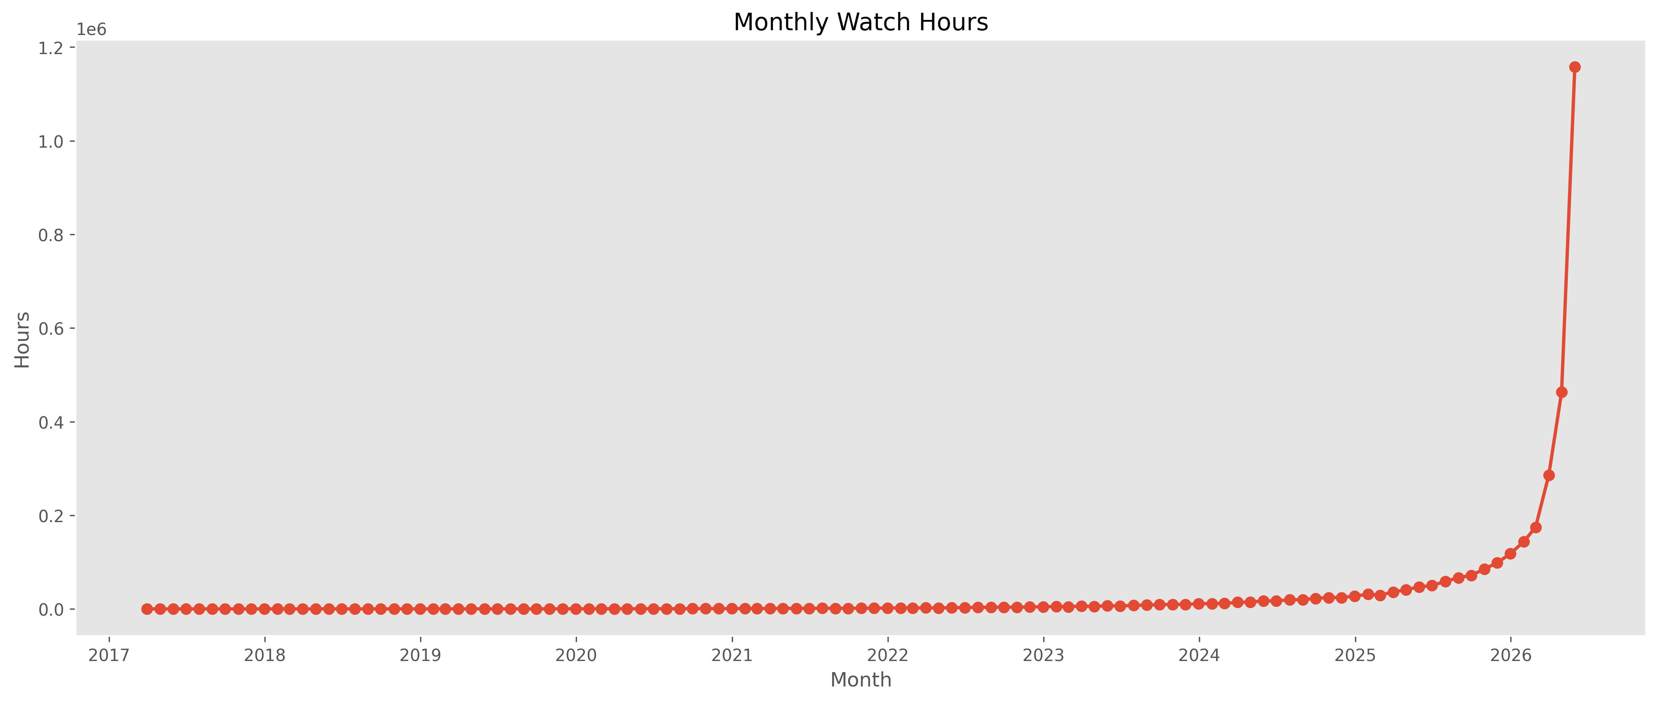
Figure 7.1 — Monthly total watch hours across the platform.
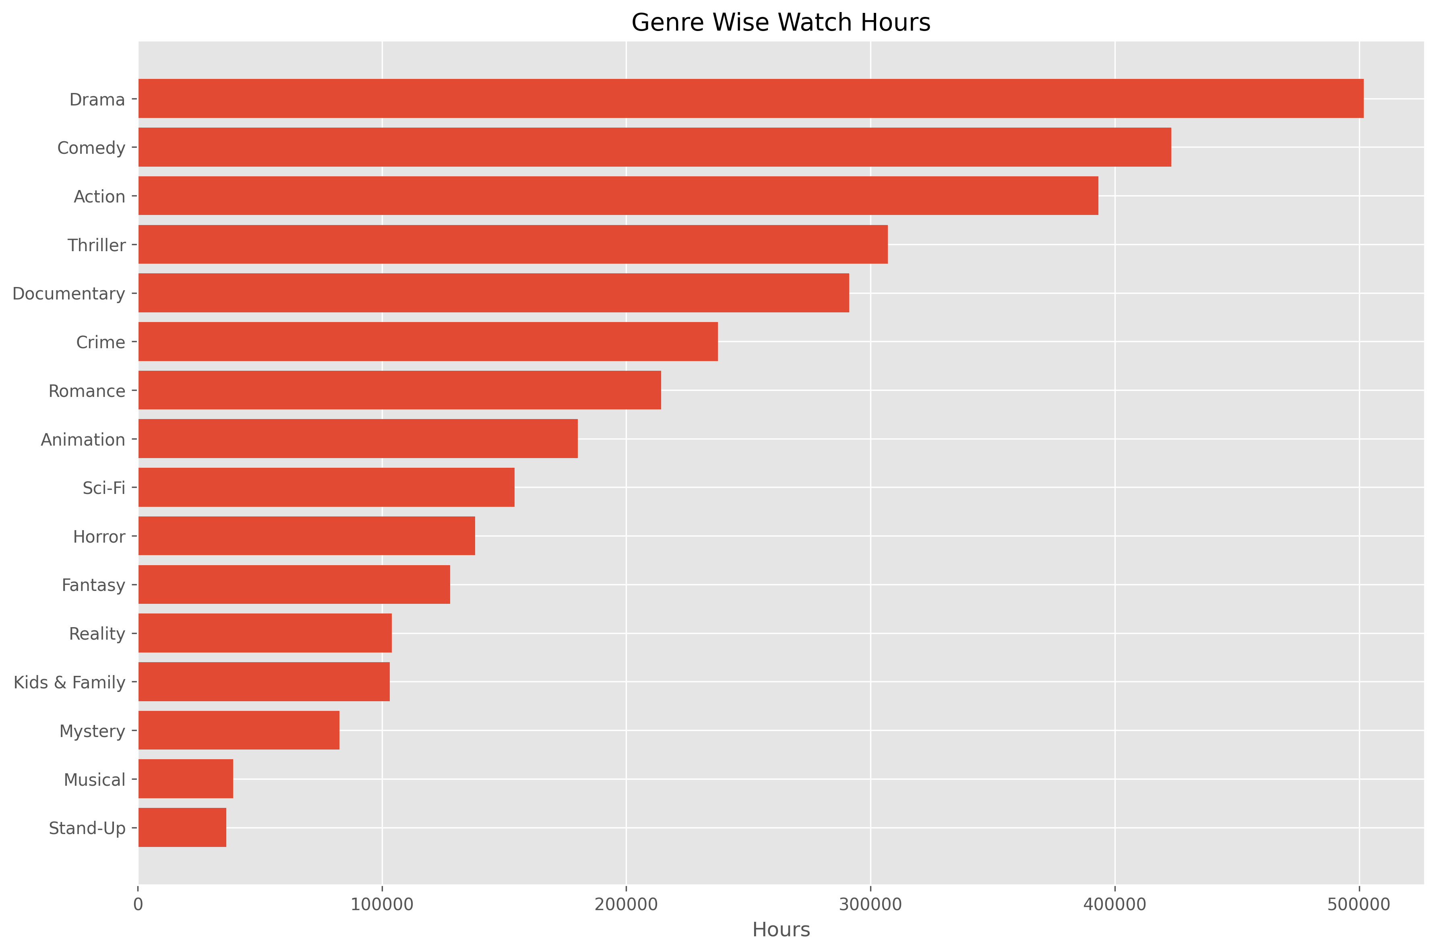
Figure 7.2 — Total watch hours by genre. Drama leads with over 500,000 hours, followed by Comedy and Action.

7.3 Content & Geography
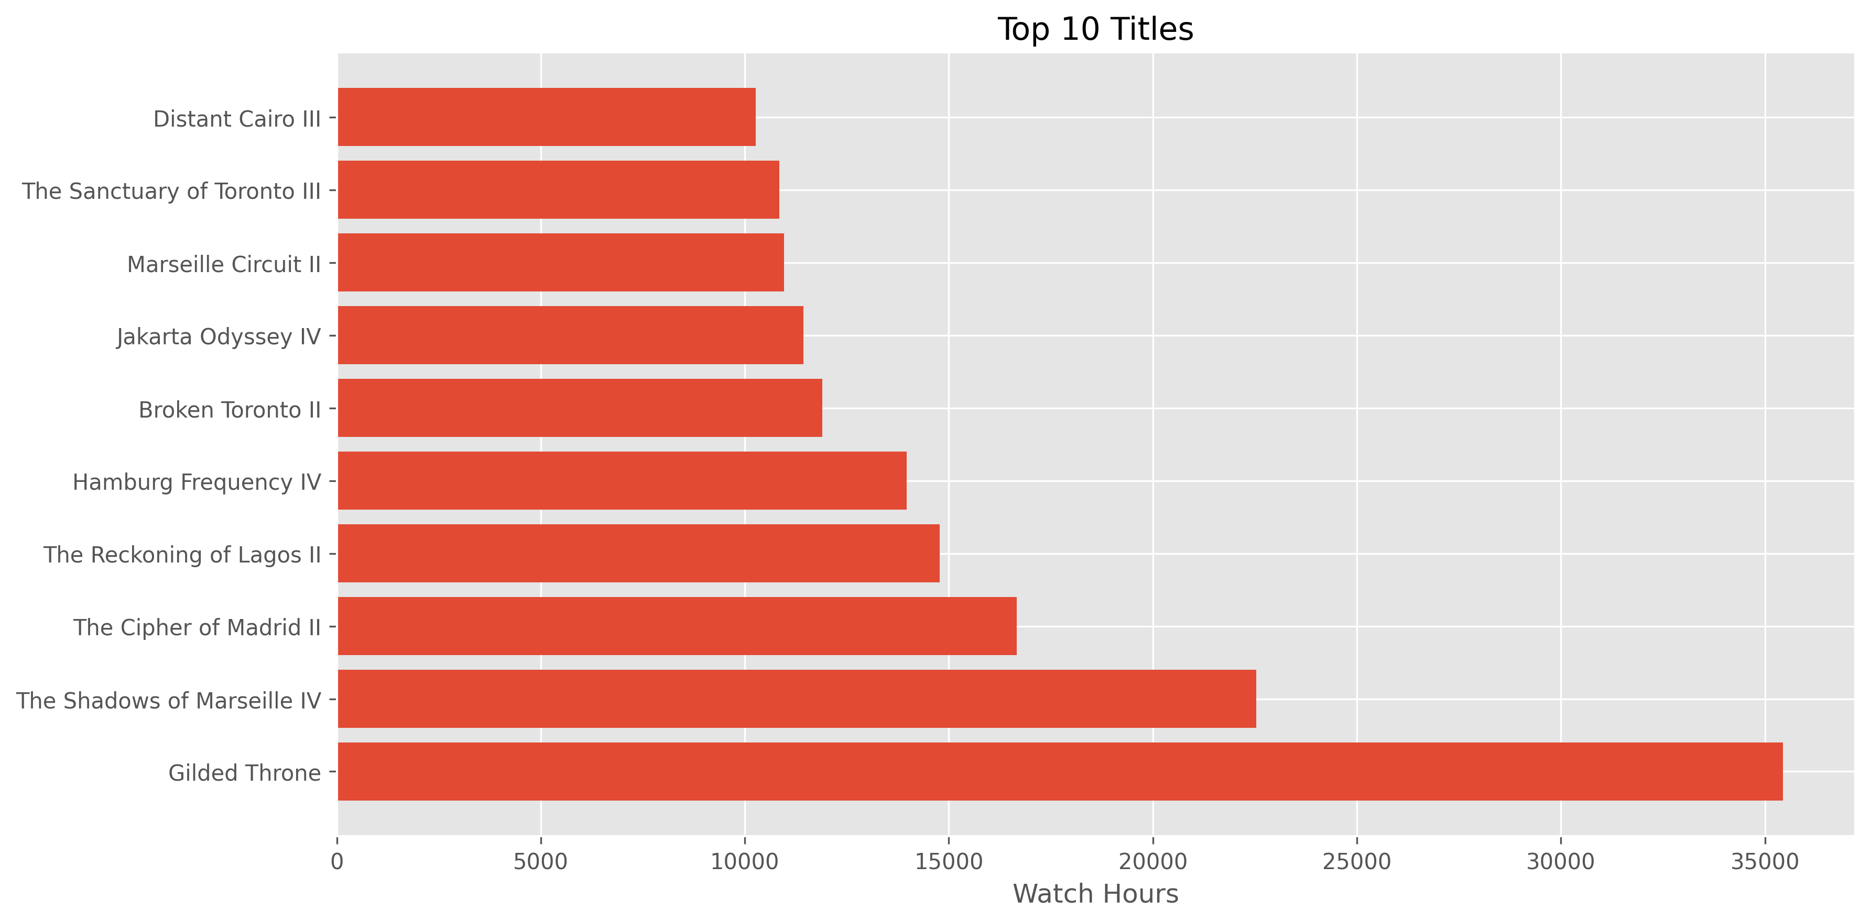
Figure 7.3 — Top 10 titles by watch hours, led by “Gilded Throne” at 35,443 hours.
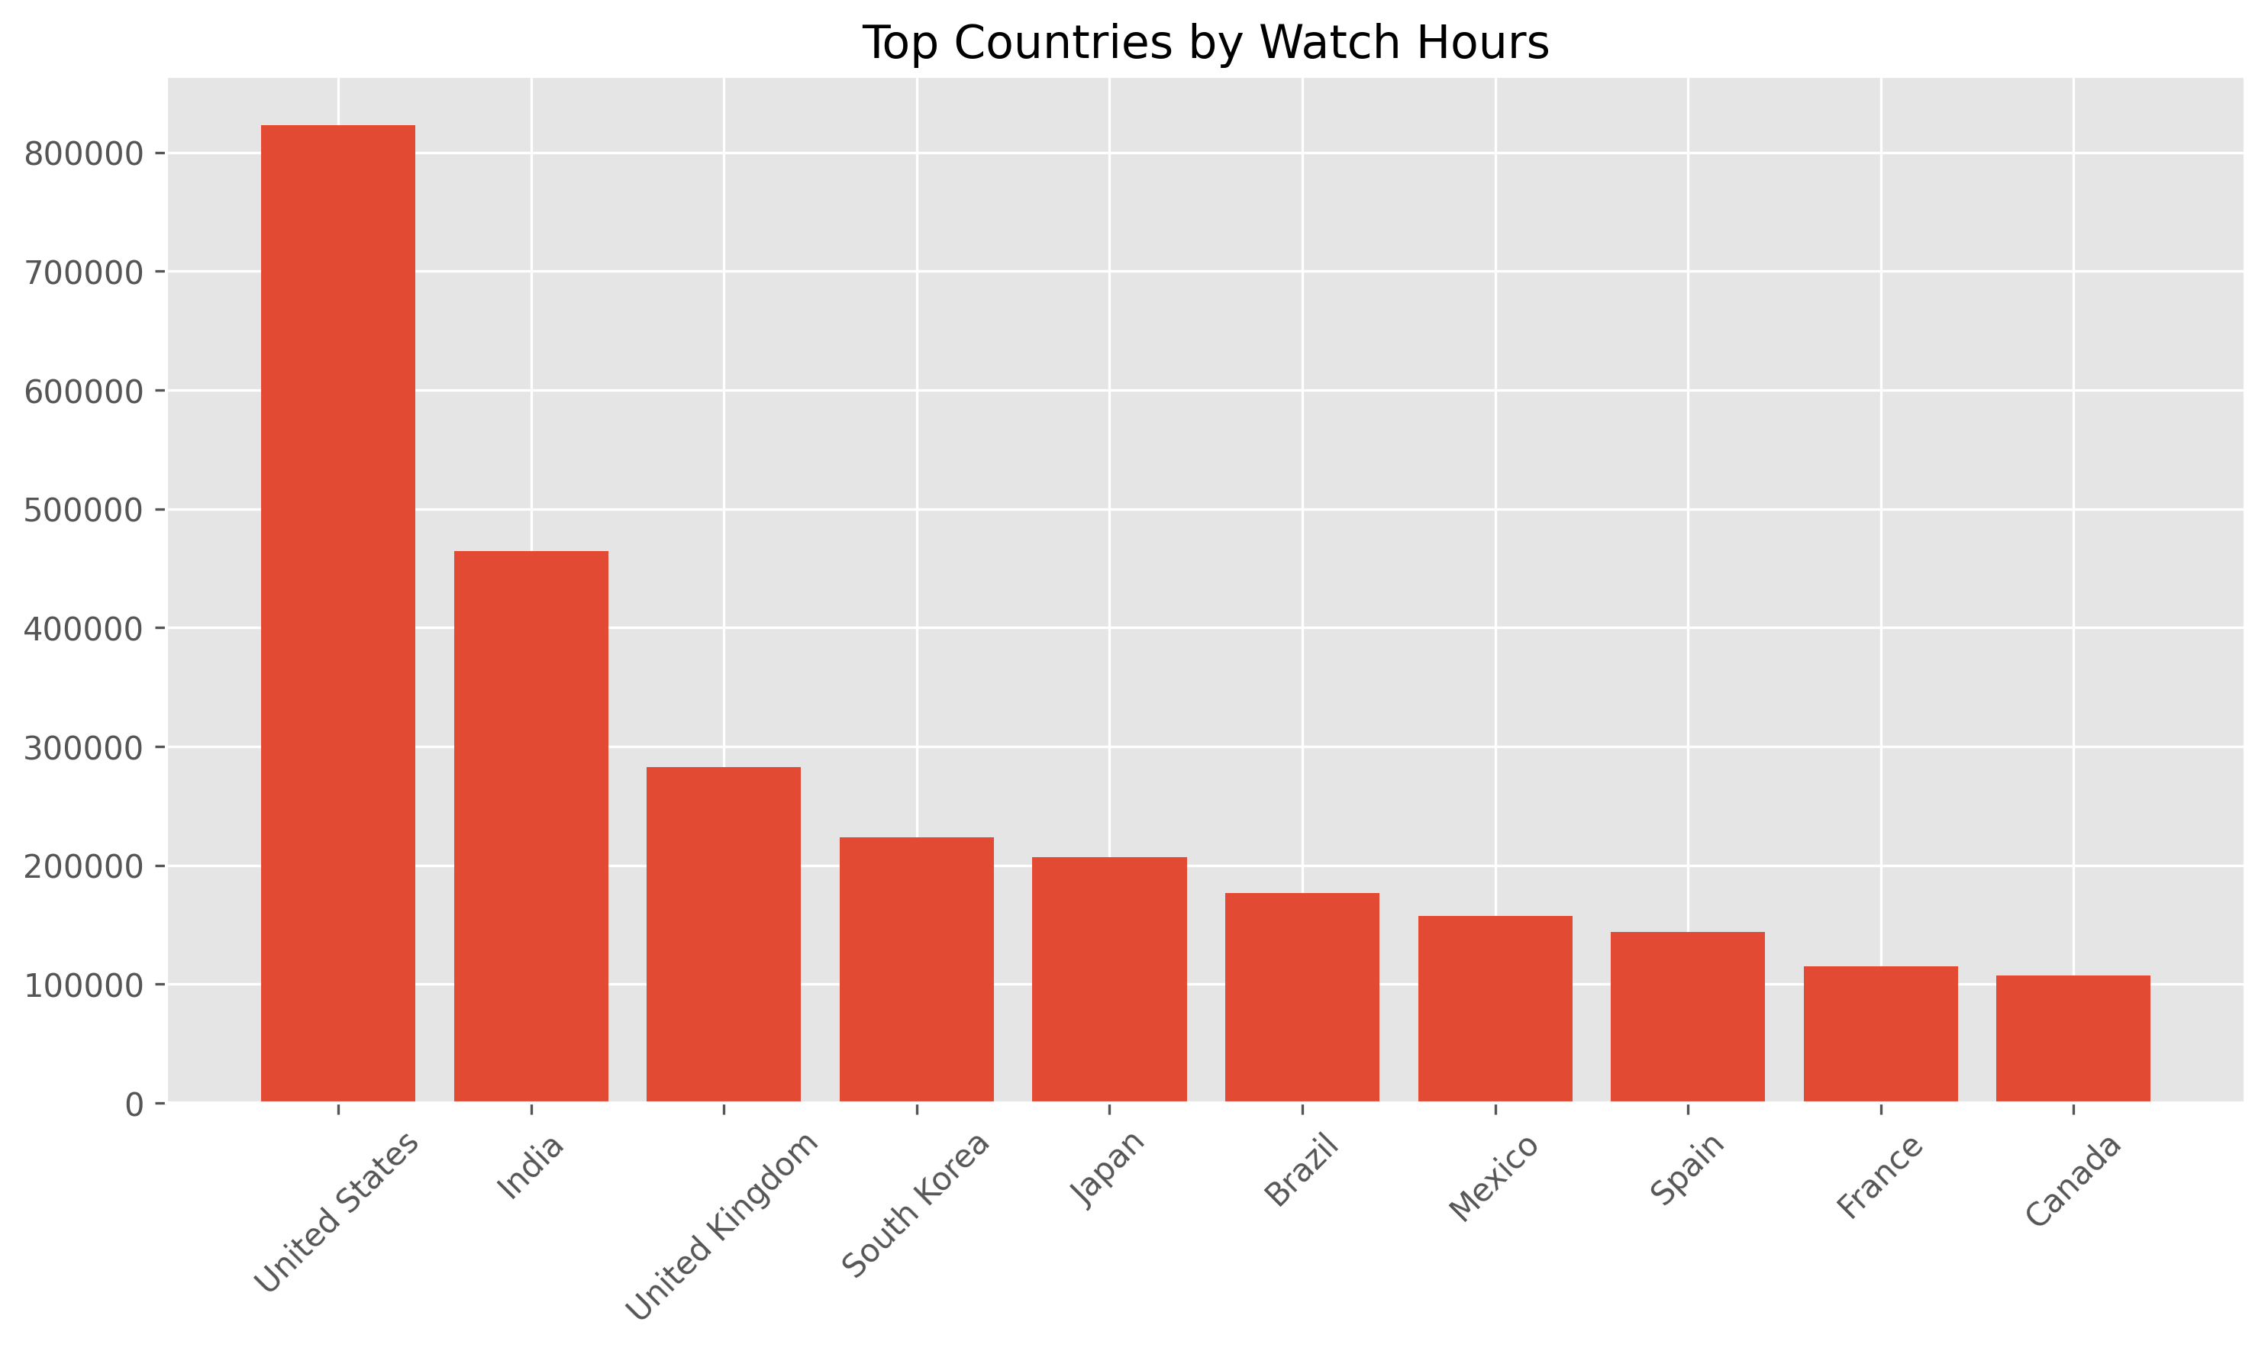
Figure 7.4 — Top countries by watch hours; the United States, India, and the United Kingdom lead subscriber and viewing volume.
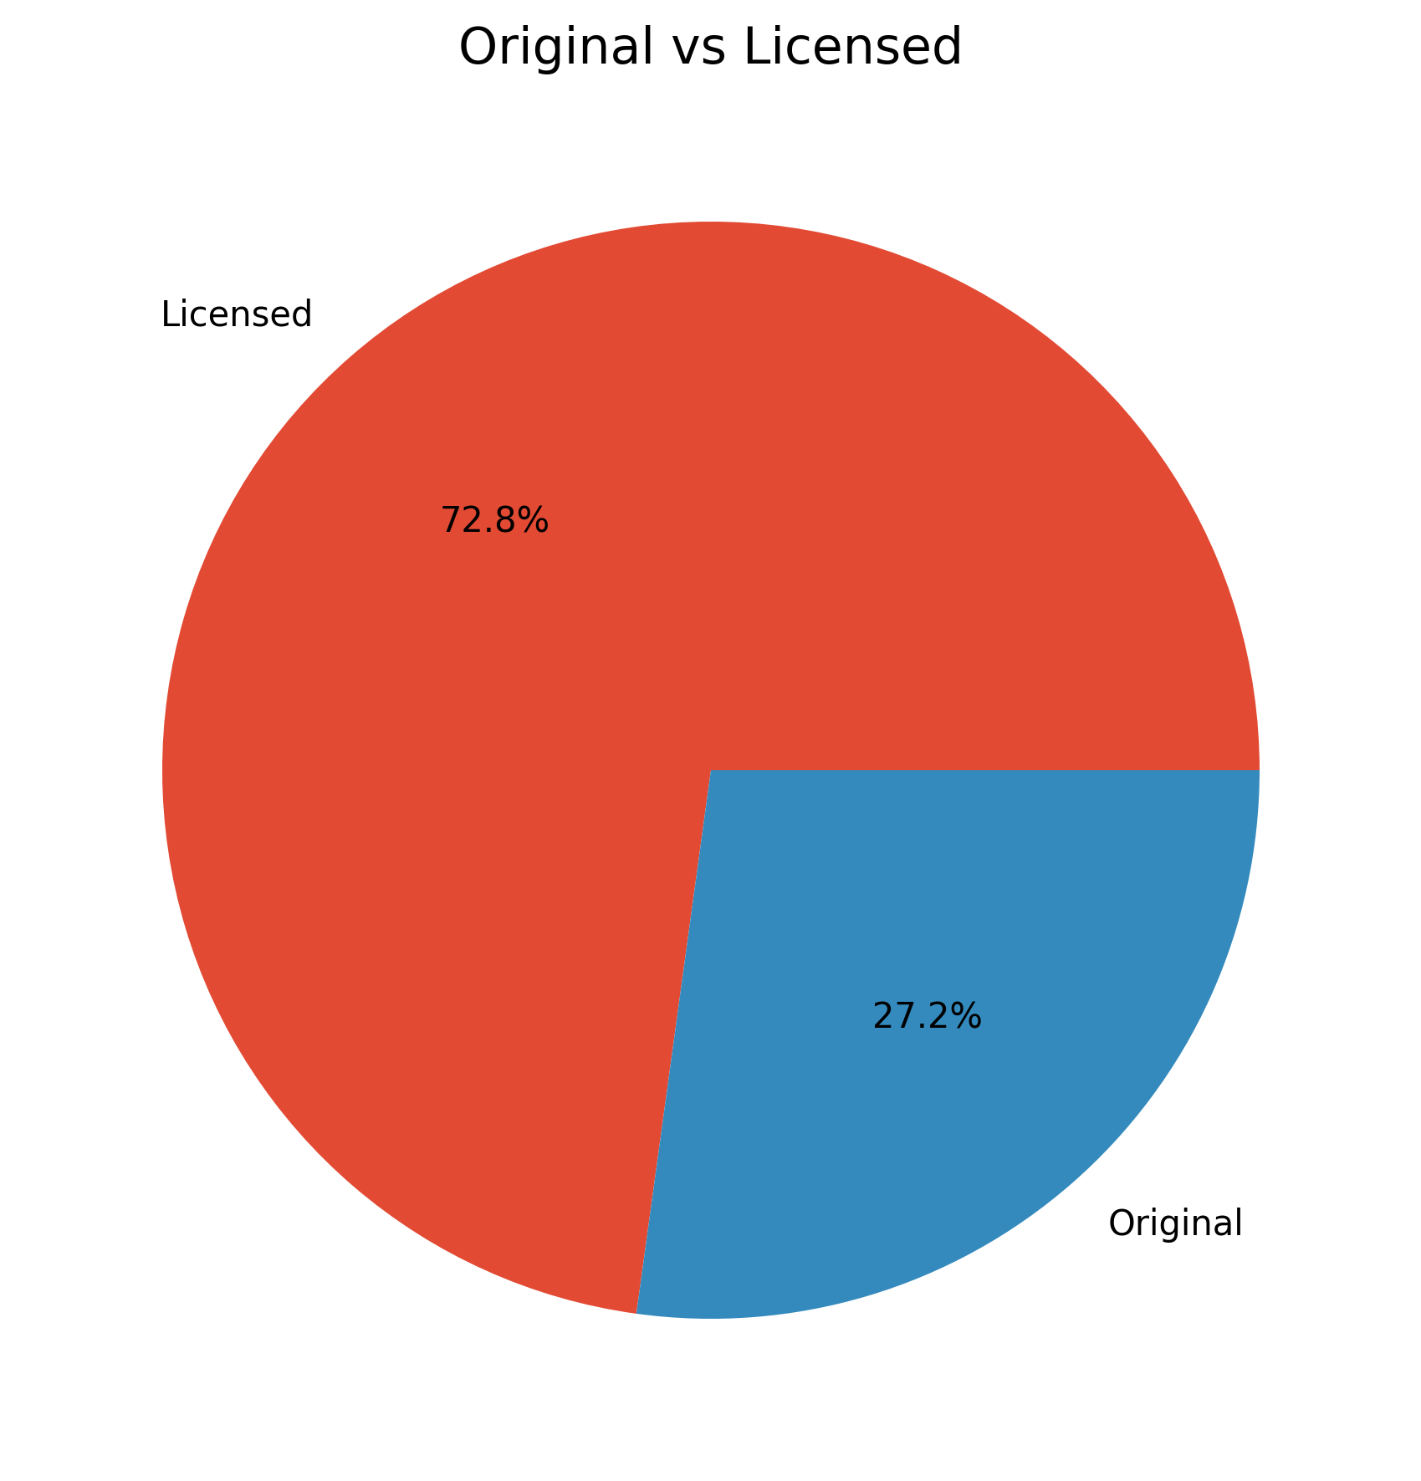
Figure 7.5 — Split between StreamFlix Original and Licensed titles (1,966 Originals vs. 7,034 Licensed).

7.4 Device Usage & Demographics
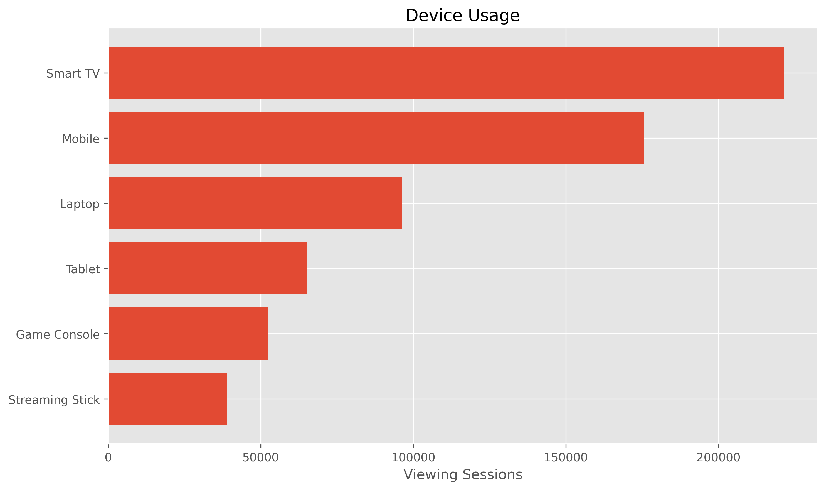
Figure 7.6 — Viewing sessions by device; Smart TV is the leading device (221,446 sessions), followed by Mobile.
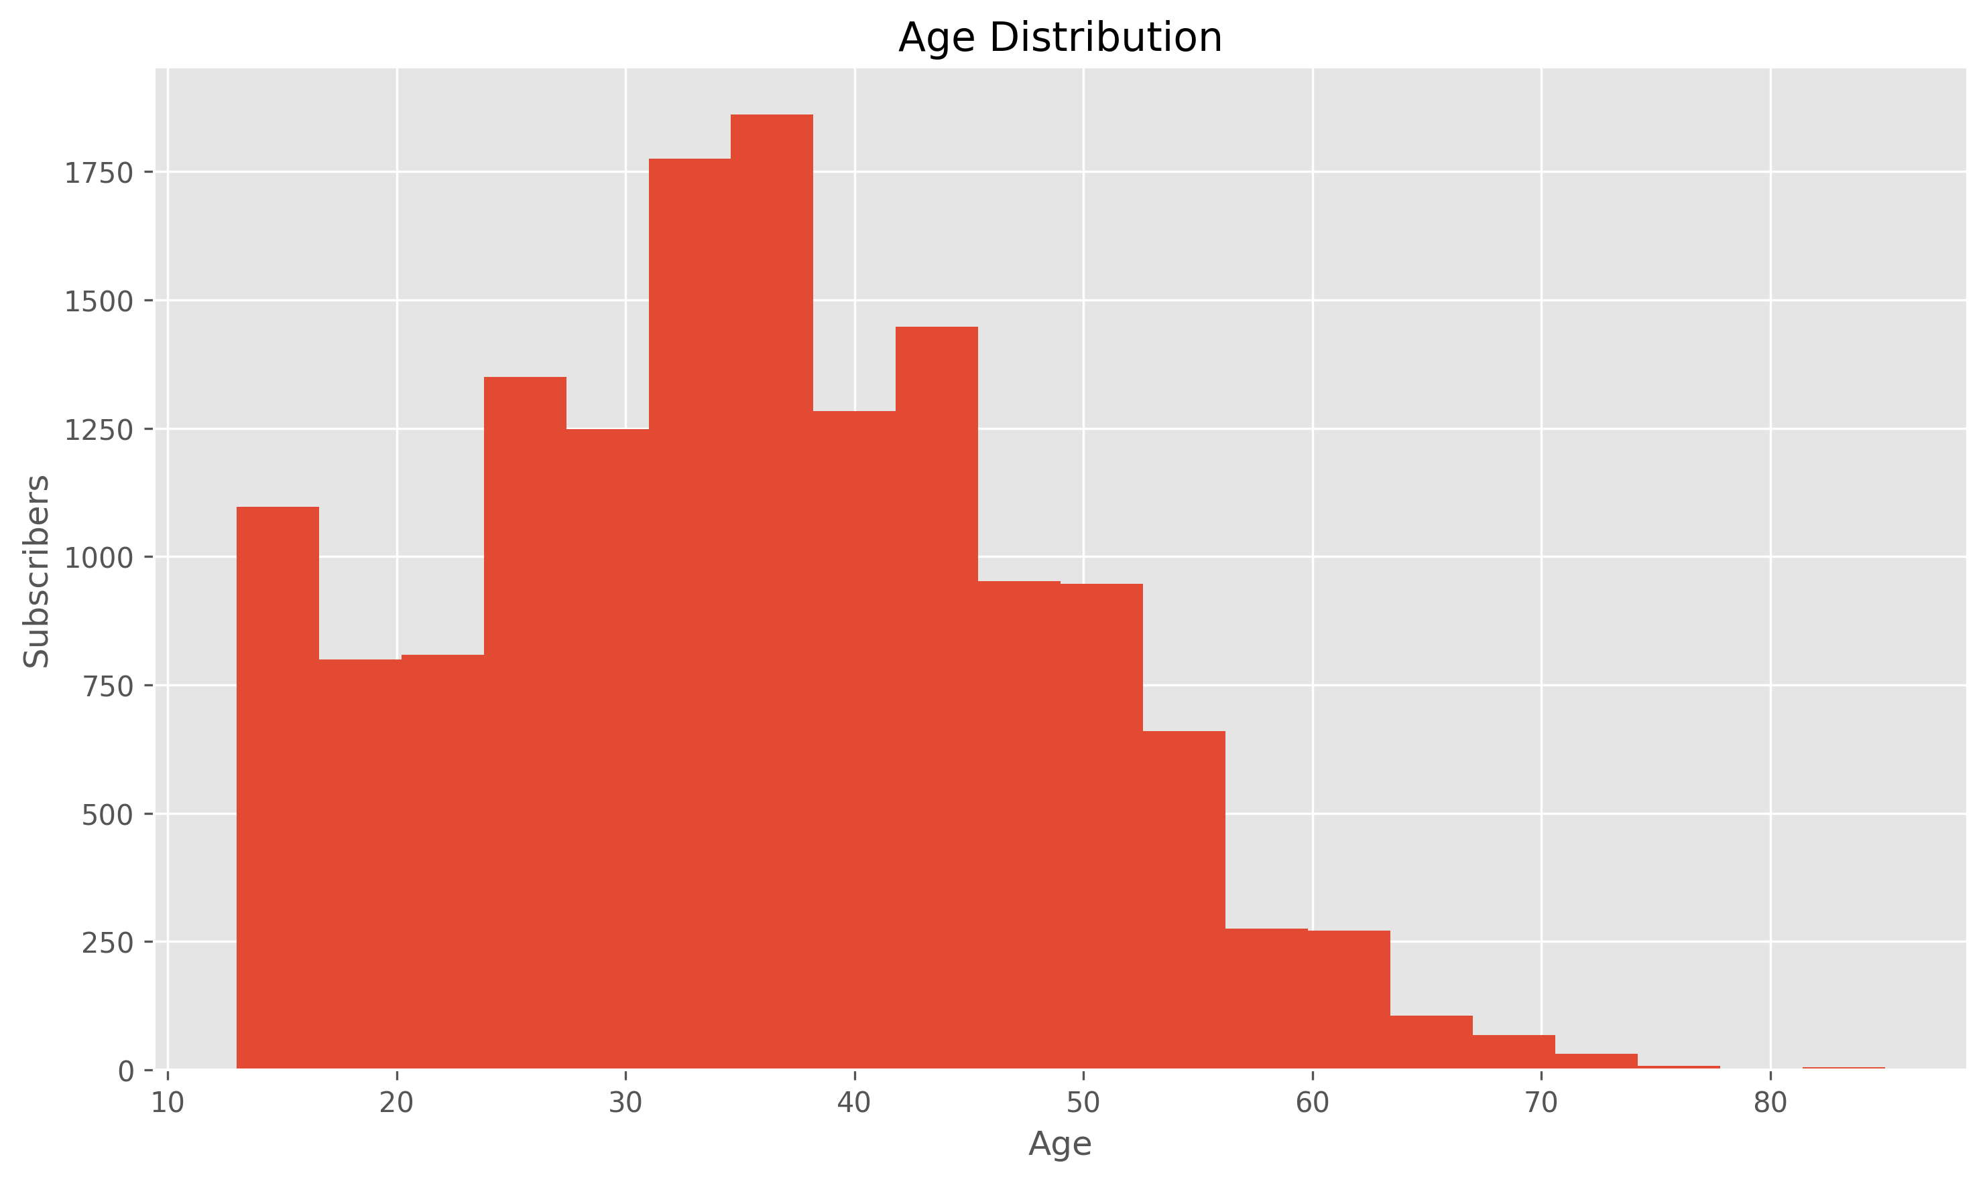
Figure 7.7 — Subscriber age distribution.

7.5 Ratings & Sentiment
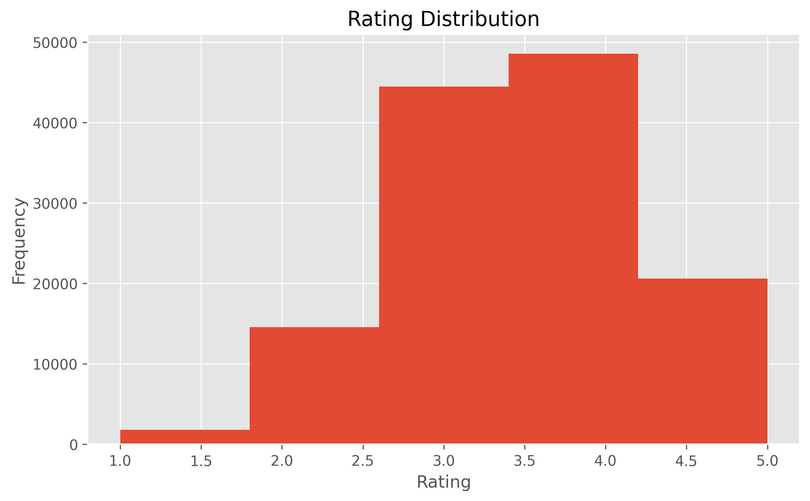
Figure 7.8 — Distribution of user ratings (average rating: 3.55 / 5).
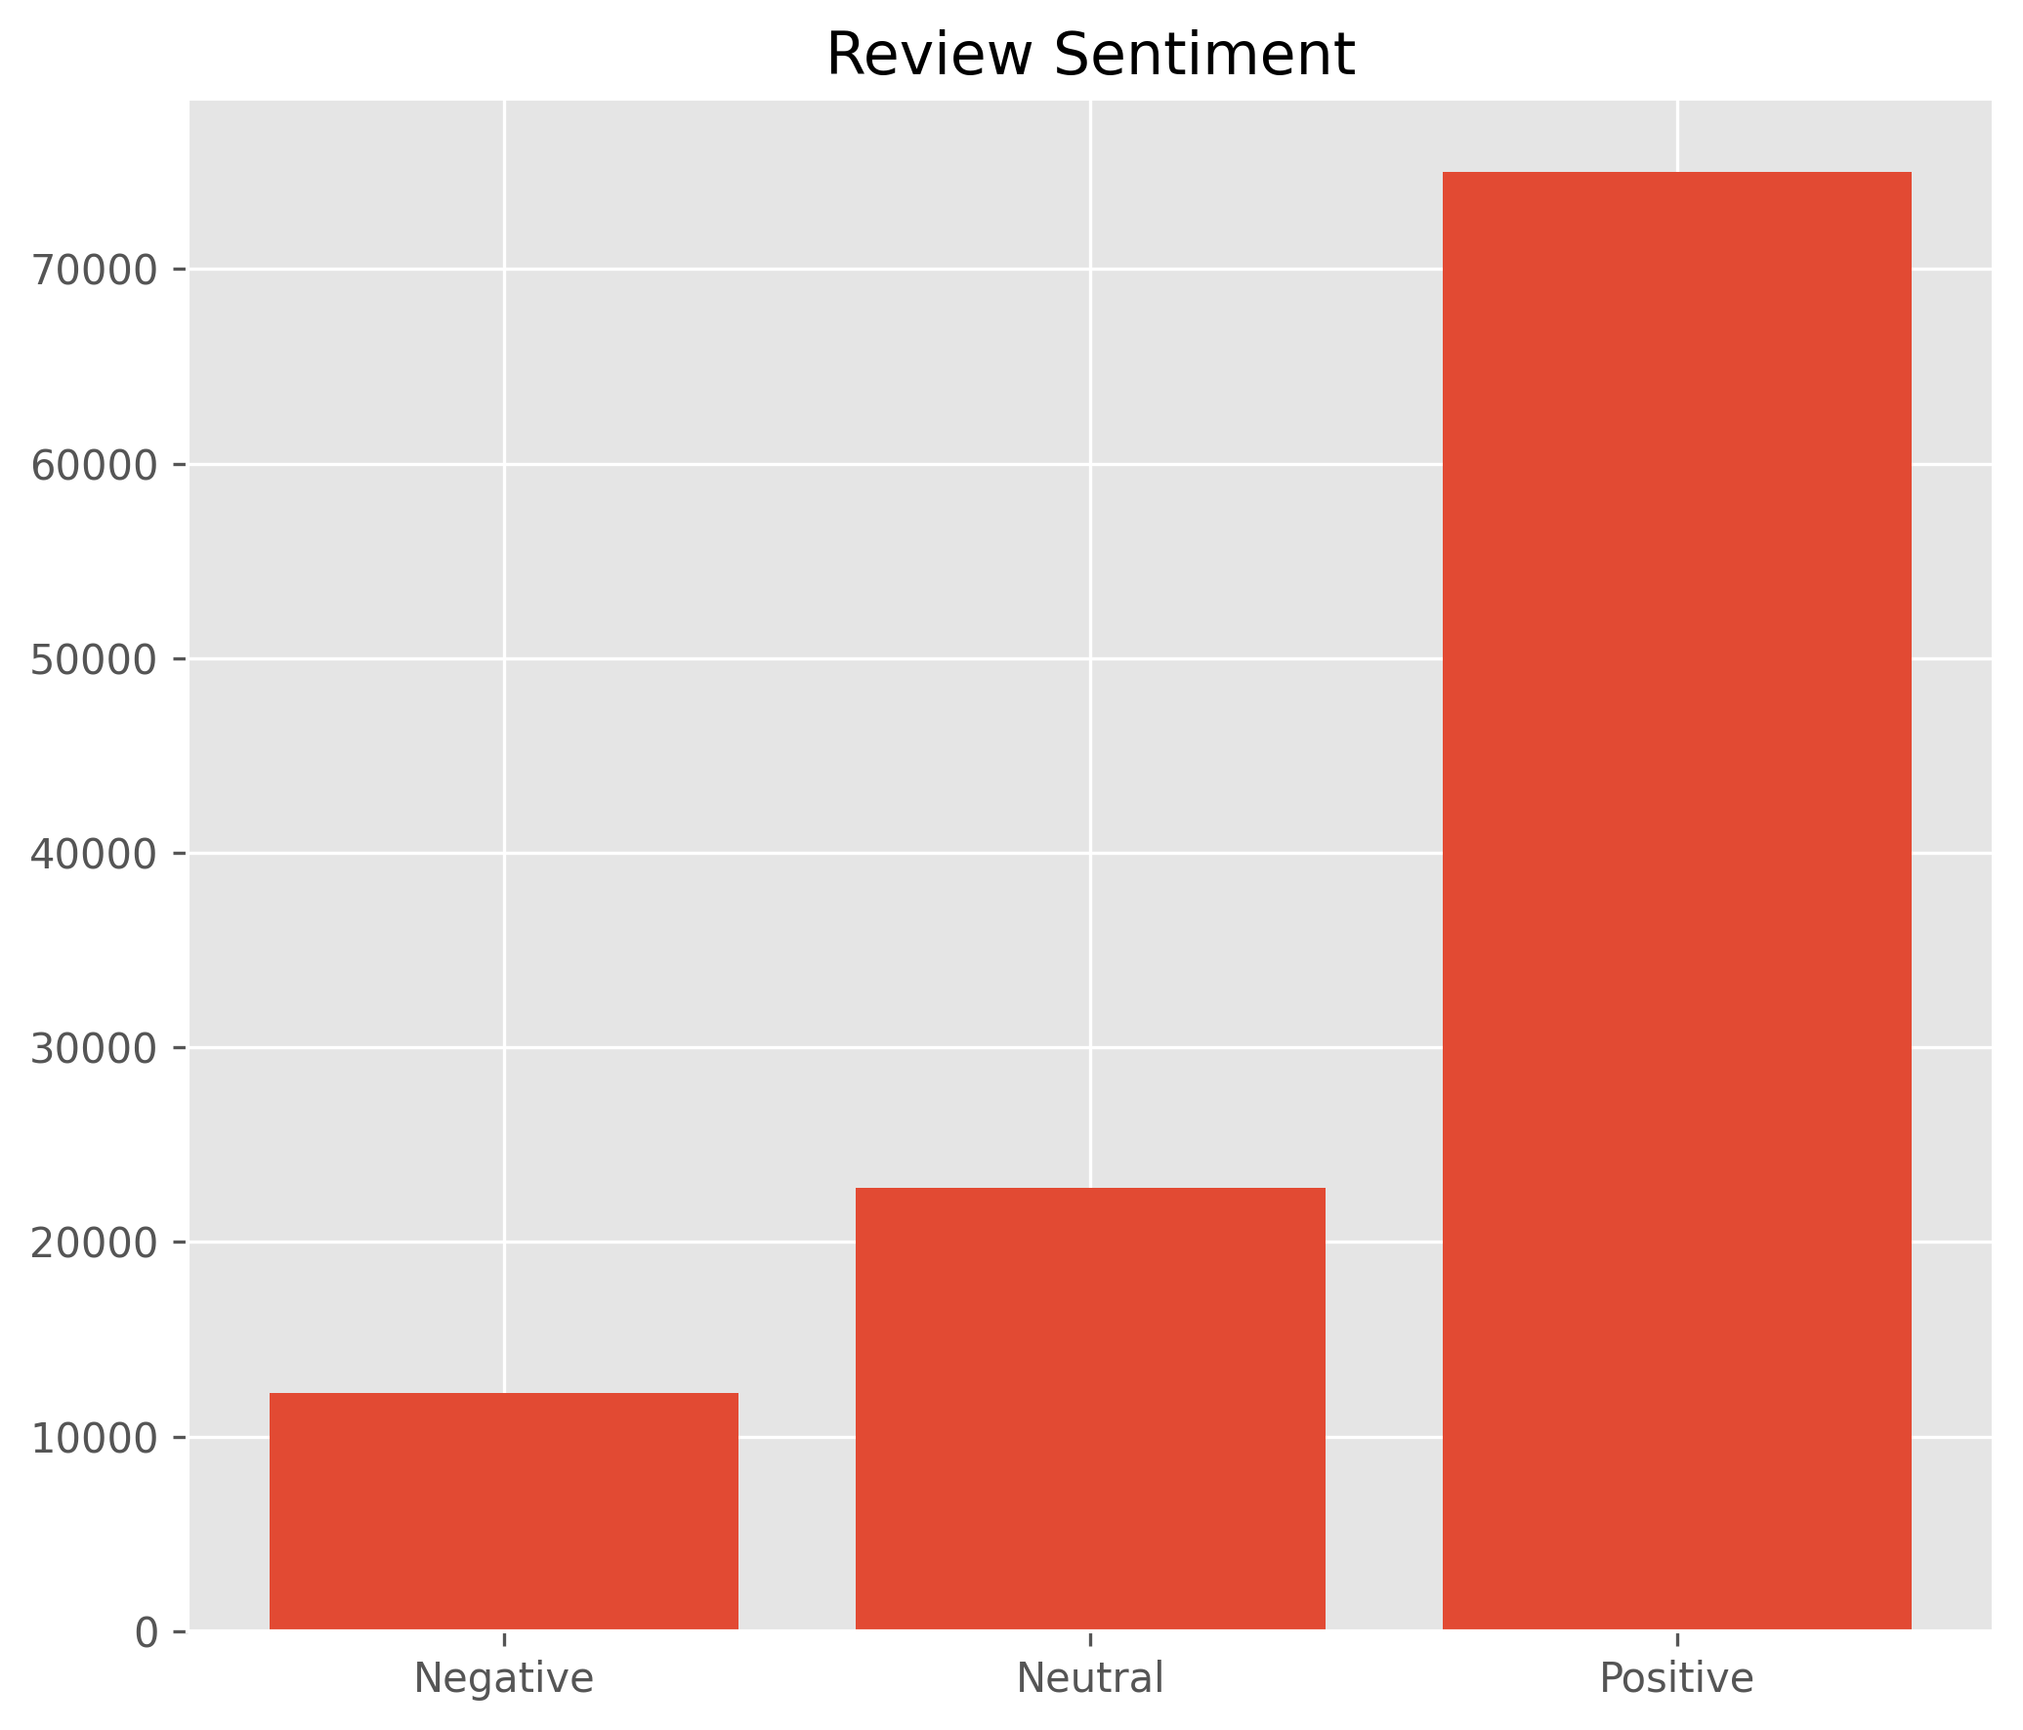
Figure 7.9 — Review sentiment breakdown across 110,000 reviews.

7.6 Correlation Analysis
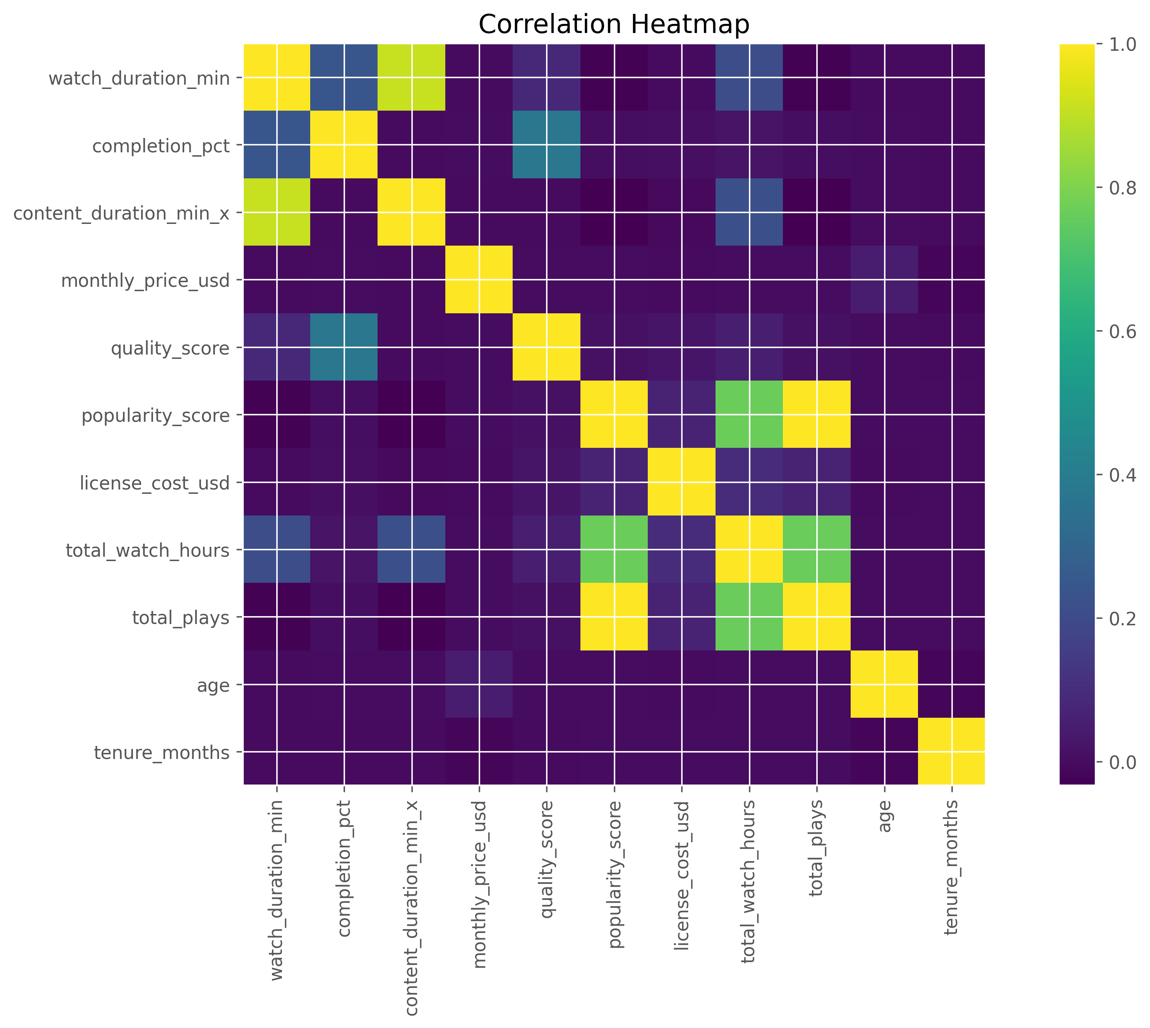
Figure 7.10 — Correlation heatmap across key numeric engagement and content variables.

7.7 Key EDA Observations
- Drama is the top genre by total watch hours (501,884 hours), followed by Comedy (423,149) and Action (393,172).
- Smart TV is the dominant viewing device (221,446 sessions), ahead of Mobile (175,605) and Laptop (96,408).
- The United States, India, and the United Kingdom are the three largest markets by both subscribers and watch hours.
- Completion rate is remarkably consistent across genres and devices, hovering around 65%, suggesting content pacing rather than device or genre is the primary driver of drop-off.
- Licensed content (7,034 titles) far outnumbers Originals (1,966 titles), yet Originals already account for 27.17% of total watch hours — a strong per-title efficiency signal.
Chapter Summary: This chapter presented the exploratory analysis of viewing behavior, content, geography, devices, demographics, and sentiment, highlighting Drama and Smart TV as the leading genre and device, and the strong per-title efficiency of Original content. The next chapter formalizes these patterns into business KPIs.

Chapter 8 — Key Performance Indicator (KPI) Analysis

8.1 Introduction
KPIs were developed to monitor subscriber growth, customer engagement, content performance, revenue generation, and platform efficiency. They were calculated in Python and mirrored in Power BI using DAX (see Appendix F), forming the analytical core of this report and the executive dashboard.

8.2 KPI Summary Table
KPI | Value
Total Subscribers | 15,000
Active Subscribers | 11,199
Active Rate | 74.66%
Churned Subscribers | 3,801
Churn Rate | 25.34%
Total Watch Hours | 3,333,467.73
Average Watch Hours per Session | 5.13
Average Watch Time per Subscriber (hrs) | 222.26
Completion Rate | 65.31%
Monthly Revenue (billed) | $227,772.00
Monthly Recurring Revenue (MRR) | $175,868.51
Average Revenue Per User (ARPU) | $15.70
Total Titles | 9,000 (5,336 Movies / 3,664 TV Shows)
Original Titles / Licensed Titles | 1,966 / 7,034
Original Watch-Hour Share | 27.17%
Average Rating | 3.55 / 5
Total Reviews | 110,000
Watchlist Items | 65,000
Watchlist Conversion Rate | 46.23%
Note: the Churn Rate figure above (25.34%, i.e. 3,801 of 15,000 subscribers with is_active = False) corrects an aggregation error in the original pipeline output, which had divided churned subscribers by the wrong denominator. This is consistent with the 74.66% Active Rate reported in the same output.

8.3 Subscriber KPIs

Total & Active Subscribers
Total Subscribers = COUNT(subscriber_id) = 15,000. Active Subscribers = COUNT(is_active = TRUE) = 11,199 (74.66%). This measures platform scale and current customer engagement.

Churn Rate
Churn Rate = Churned Subscribers ÷ Total Subscribers × 100 = 3,801 ÷ 15,000 × 100 = 25.34%. A quarter of the historical subscriber base has lapsed, making retention the single highest-leverage lever identified in this analysis (see Chapter 11).

8.4 Engagement KPIs

Total Watch Hours & Completion Rate
Total Watch Hours = SUM(watch_duration_min) ÷ 60 = 3,333,467.73. Completion Rate = AVERAGE(completion_pct) = 65.31%, consistent across genres and devices, indicating engagement is driven more by content selection than by platform or device experience.

8.5 Content KPIs

Top Performing Genre & Original Content Share
Drama leads all genres in total watch hours (501,884.47). Original Share = Original Watch Hours ÷ Total Watch Hours = 27.17%, a strong return given Originals represent only 21.8% of the title catalogue.

8.6 Revenue KPIs

MRR & ARPU
MRR = SUM(monthly_price_usd across active subscribers) = $175,868.51. ARPU = MRR ÷ Active Subscribers = $175,868.51 ÷ 11,199 = $15.70.
Plan | Subscribers | Revenue | Avg. Price
Standard | 6,100 | $94,489.00 | $15.49
Premium | 4,442 | $102,121.58 | $22.99
Basic with Ads | 4,458 | $31,161.42 | $6.99

8.7 Customer Experience KPIs

Average Rating & Watchlist Conversion
Average Rating = AVERAGE(rating) = 3.55 / 5 across 130,000 ratings. Watchlist Conversion Rate = Watched ÷ Watchlist Items = 46.23% of the 65,000 titles added to a watchlist were eventually watched.
Chapter Summary: This chapter formalized subscriber, engagement, content, revenue, and customer-experience KPIs with their actual computed values, correcting a churn-rate calculation error found in the raw pipeline output. The next chapter covers the SQL analysis performed against the cleaned data.
Chapter 9 — SQL Database Design and Analysis

9.1 Introduction
A relational schema was designed around the six cleaned datasets, and SQL was used to answer twelve specific business questions. All datasets satisfied referential-integrity constraints (subscriber_id and title_id) before dependent records were loaded.

9.2 Business Questions Answered
- Which genres generate the highest watch hours? — Drama, Comedy, Action.
- Which titles are the most watched? — “Gilded Throne,” “The Shadows of Marseille IV,” “The Cipher of Madrid II.”
- What is the subscriber growth trend? — See Figure 7.1 / dashboard page 3.
- Which subscription plan generates the highest revenue? — Premium ($102,121.58), ahead of Standard ($94,489.00).
- Which countries contribute the most subscribers? — United States (3,774), India (1,872), United Kingdom (1,266).
- Which devices are used most frequently? — Smart TV (221,446 sessions), Mobile (175,605).
- How satisfied are subscribers with the available content? — Average rating of 3.55 / 5 across 130,000 ratings.
- Which titles have the highest ratings? — Assessed via the Ratings table joined to Titles.
- What percentage of reviews are positive? — See sentiment split, Figure 7.9.
- Which licensed titles are nearing expiry? — Flagged via license_expiry in the Titles table for renewal planning.
- How effective is the watchlist feature? — 46.23% conversion rate from watchlist to watched.
- Which genres provide the highest return on investment? — Assessed by combining watch hours against license_cost_usd by genre.

9.3 Approach
Queries were grouped into twelve numbered SQL outputs (Q1–Q12), covering genre performance, country performance, engagement by release year, movies vs. TV shows, language performance, genre completion rate, engagement by plan, device usage share, subscriber churn, monthly recurring revenue, watchlist conversion, and content investment efficiency — each exported as a standalone CSV for validation and reporting.
Chapter Summary: This chapter summarized the star-schema design and the twelve business questions answered via SQL, matching the questions originally scoped in Chapter 2. The next chapter presents the Power BI dashboard built on top of this data model.

Chapter 10 — Power BI Dashboard Development

10.1 Introduction
An interactive, five-page Power BI dashboard was built on the star-schema data model to give executives a single, consistent view of engagement, content, subscribers, customer experience, and catalogue investment.

10.2 Page 1 — Engagement Overview
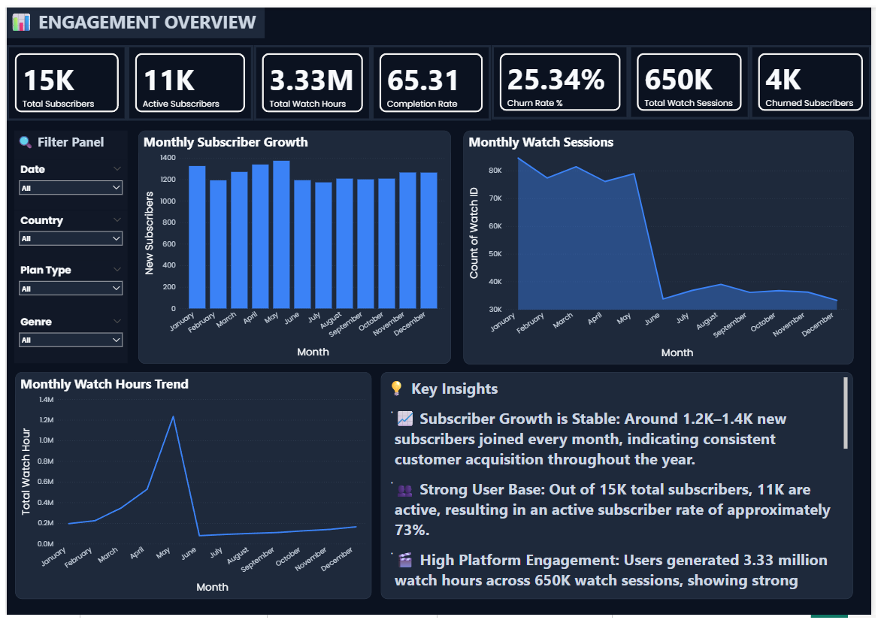
Figure 10.1 — Engagement Overview: total watch hours, completion rate, top genres, top countries, and device split.

10.3 Page 2 — Content Performance
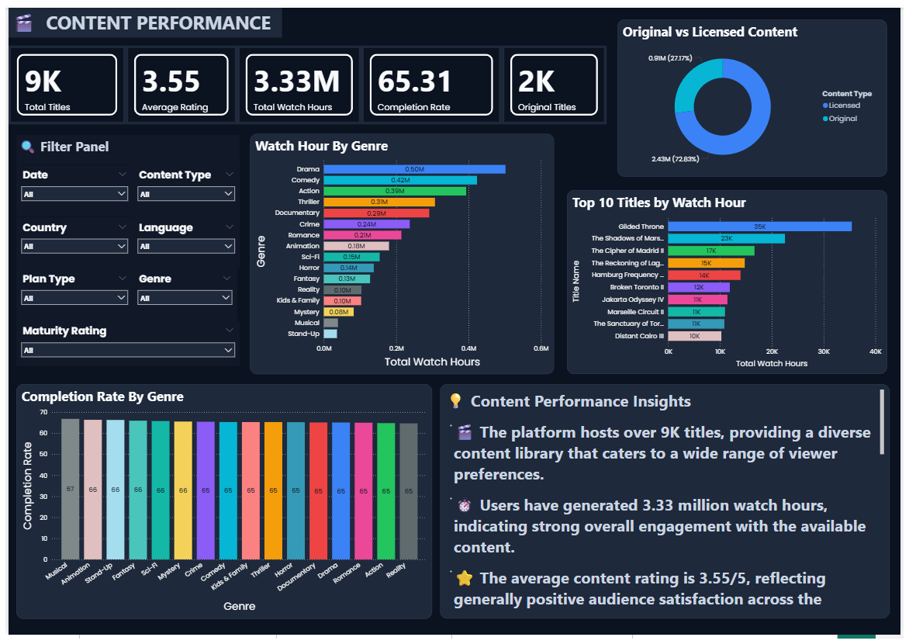
Figure 10.2 — Content Performance: top titles, genre performance, and Original vs. Licensed comparison.

10.4 Page 3 — Subscriber Insights
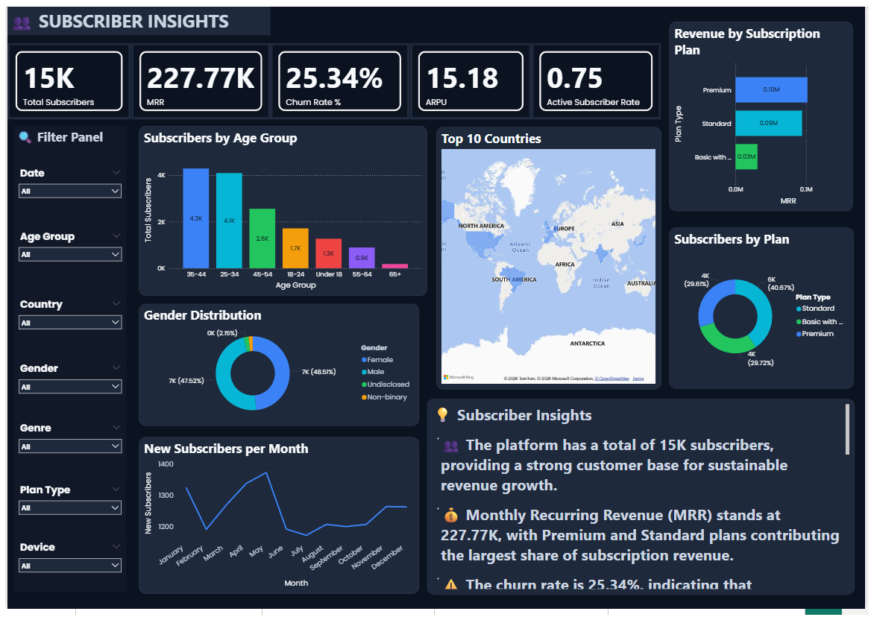
Figure 10.3 — Subscriber Insights: subscriber growth, plan distribution, and demographic breakdowns.

10.5 Page 4 — Customer Experience
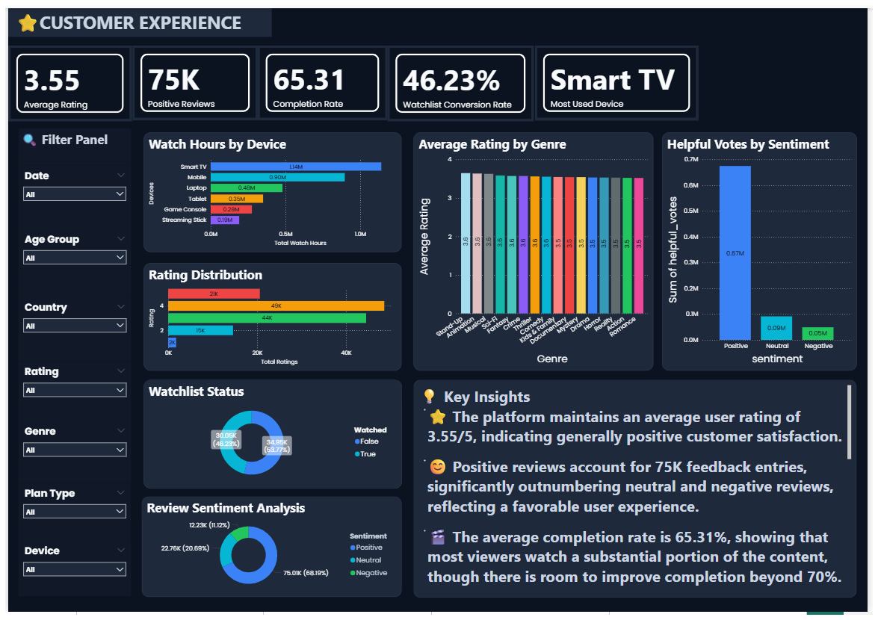
Figure 10.4 — Customer Experience: rating distribution, sentiment, and watchlist conversion.

10.6 Page 5 — Catalogue & Investment
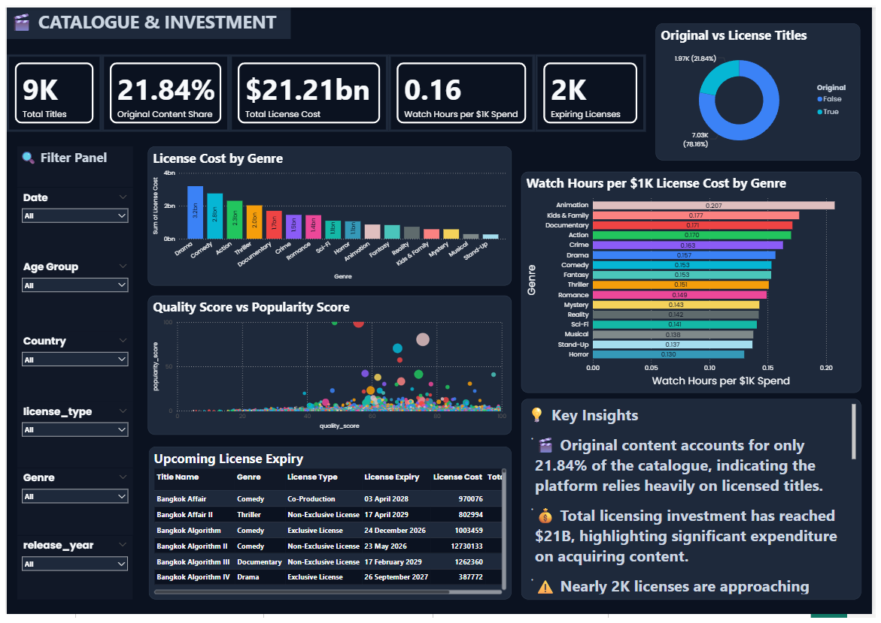
Figure 10.5 — Catalogue & Investment: licensing spend, Original vs. Licensed investment, and content ROI by genre.

10.7 Data Model
The dashboard is powered by a star schema with Dim_Subscribers and Dim_Titles as dimension tables, and Fact_Watch, Fact_Rating, Fact_Review, and Fact_Watchlist as fact tables (full diagram in Appendix G), enabling fast filtering and consistent measures across all five pages.
Chapter Summary: This chapter presented all five pages of the Power BI dashboard and the underlying star-schema model. The final chapter draws together the business insights and recommendations that follow from the analysis.

Chapter 11 — Business Insights & Recommendations

11.1 Key Business Insights
- Drama is the top-performing genre by watch hours (501,884.47), followed by Comedy and Action — content acquisition budgets are best weighted toward these three genres.
- Smart TV is the leading viewing device (221,446 sessions, 1,133,405 watch hours), ahead of Mobile — the in-living-room, lean-back experience should remain the primary design target.
- Original content drives 27.17% of watch hours from just 21.8% of the catalogue, a stronger per-title return than Licensed content.
- The United States, India, and the United Kingdom are the three largest markets by subscribers and watch hours, together representing a substantial share of the platform's revenue.
- Churn stands at 25.34% (3,801 of 15,000 subscribers), while active subscribers still average 222.26 watch hours — engagement is not the barrier to retention; something else is driving cancellations.
- Completion rate is stable at ~65% across genres and devices, suggesting content length/pacing, not device or genre, is the main driver of drop-off.
- Watchlist conversion sits at 46.23%, meaning more than half of watchlisted titles are never watched — a clear re-engagement opportunity.
- Average content rating is 3.55 / 5, with a mixed but largely constructive review-sentiment profile.

11.2 Recommendations
- Prioritize retention: launch targeted win-back and loyalty campaigns for at-risk segments, given the 25.34% churn rate against a healthy 65.31% completion rate — the drop-off is not an engagement problem, so retention efforts should look at pricing, plan fit, and competitive alternatives rather than content quality alone.
- Increase investment in Original content, particularly in Drama, Comedy, and Action, given its outsized watch-hour share relative to catalogue size.
- Improve the content recommendation system to lift the 46.23% watchlist-to-watched conversion rate, e.g. through reminder nudges and better personalization.
- Continue to optimize for Smart TV and Mobile as the two dominant device experiences, while monitoring emerging device categories.
- Review and renew licensed titles approaching license_expiry proactively, prioritized by their historical watch-hour contribution.
- Use review sentiment and rating trends as an early-warning signal for content quality issues, feeding back into acquisition and production decisions.

11.3 Conclusion
The StreamFlix Content Analytics project demonstrates a complete, real-world analytics workflow — from raw, messy data through to an executive-ready Power BI dashboard — using Python, SQL, and Power BI. The resulting KPIs and dashboard give StreamFlix's management a clear, data-driven view of platform performance and a concrete set of levers, chiefly retention and Original content investment, to improve it.
Chapter Summary: This chapter presented the key business insights and actionable recommendations drawn from the full analysis, closing out the main body of the report. Appendices follow with supporting technical detail.

Appendix A — Star Schema Design
Dimension tables: Dim_Subscribers, Dim_Titles. Fact tables: Fact_Watch, Fact_Rating, Fact_Review, Fact_Watchlist. Each fact table relates to both dimension tables via subscriber_id and/or title_id, enabling flexible slicing across subscriber and content attributes.
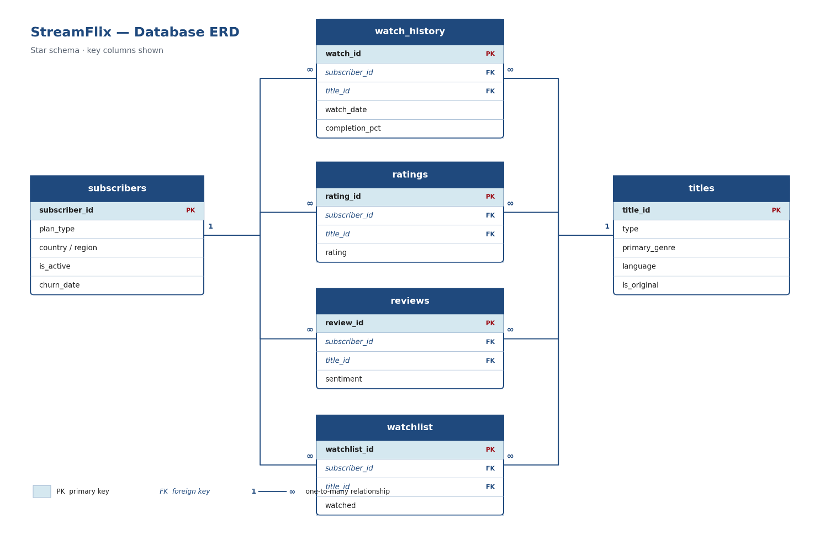

Appendix B — DAX Measures
- Total Subscribers = DISTINCTCOUNT(Subscribers[subscriber_id])
- Active Subscribers = CALCULATE(COUNT(Subscribers[subscriber_id]), Subscribers[is_active]=TRUE())
- Total Watch Hours = SUM(Watch_History[watch_duration_min])/60
- Completion Rate = AVERAGE(Watch_History[completion_pct])
- Churn Rate = DIVIDE(COUNTROWS(FILTER(Subscribers, Subscribers[is_active]=FALSE())), COUNTROWS(Subscribers))
- Average Rating = AVERAGE(Ratings[rating])
- MRR = SUM(Subscribers[monthly_price_usd])
- ARPU = DIVIDE([MRR], [Active Subscribers])

Appendix C — Python Workflow
Import Libraries → Load CSV Files → Data Cleaning → Feature Engineering → EDA → KPI Calculation → Export Cleaned Data.

Key Functions Used
- Data Loading: read_csv(), head(), info(), describe()
- Data Cleaning: drop_duplicates(), fillna(), astype(), rename(), to_datetime()
- Data Analysis: groupby(), value_counts(), agg(), merge()
- Visualization: bar(), hist(), scatter(), boxplot(), imshow()

Appendix D — Challenges Encountered
- Handling structurally-expected missing values without over-imputing.
- Confirming the absence of duplicate records across six large datasets.
- Standardizing categorical values and data types across sources.
- Reconciling a churn-rate calculation discrepancy in the automated KPI pipeline (corrected in Chapter 8).
- Designing an efficient star schema to keep Power BI performant at 650,000+ fact rows.
- Creating DAX measures that exactly mirror the Python-calculated KPIs.

Appendix E — Skills Gained

Technical Skills
- Python Programming
- Pandas & NumPy
- SQL
- Power BI & DAX
- Data Cleaning
- Exploratory Data Analysis
- Data Visualization
- KPI Development
- Star Schema Design

Professional Skills
- Analytical Thinking
- Business Problem Solving
- Data Storytelling
- Dashboard Design
- Technical Documentation
- Report Writing
- Time Management
- Communication Skills

Appendix F — References
- Python Software Foundation. Python Documentation. docs.python.org/3/
- Pandas Development Team. Pandas Documentation. pandas.pydata.org/docs/
- NumPy Developers. NumPy Documentation. numpy.org/doc/
- Microsoft. Power BI Documentation. learn.microsoft.com/power-bi/
- Microsoft. DAX Documentation. learn.microsoft.com/dax/
- Microsoft. SQL Documentation. learn.microsoft.com/sql/
- Matplotlib Development Team. Matplotlib Documentation. matplotlib.org/stable/
- Project datasets: StreamFlix Content Analytics Project (Internship Dataset).
End of Report
Internship Organization: Intermo | Project: StreamFlix Content Analytics | Intern: Sujal Pal | Role: Data Analytics Intern (Ongoing)

